Original email Dr. Webb sent to the journalism department on May 9.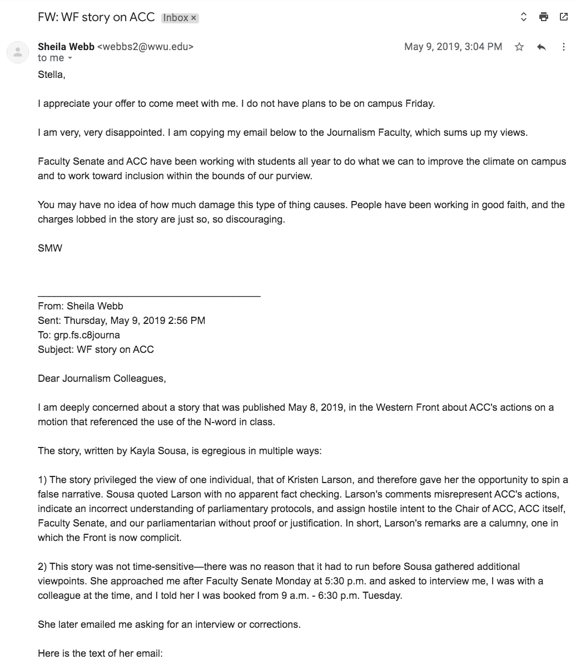
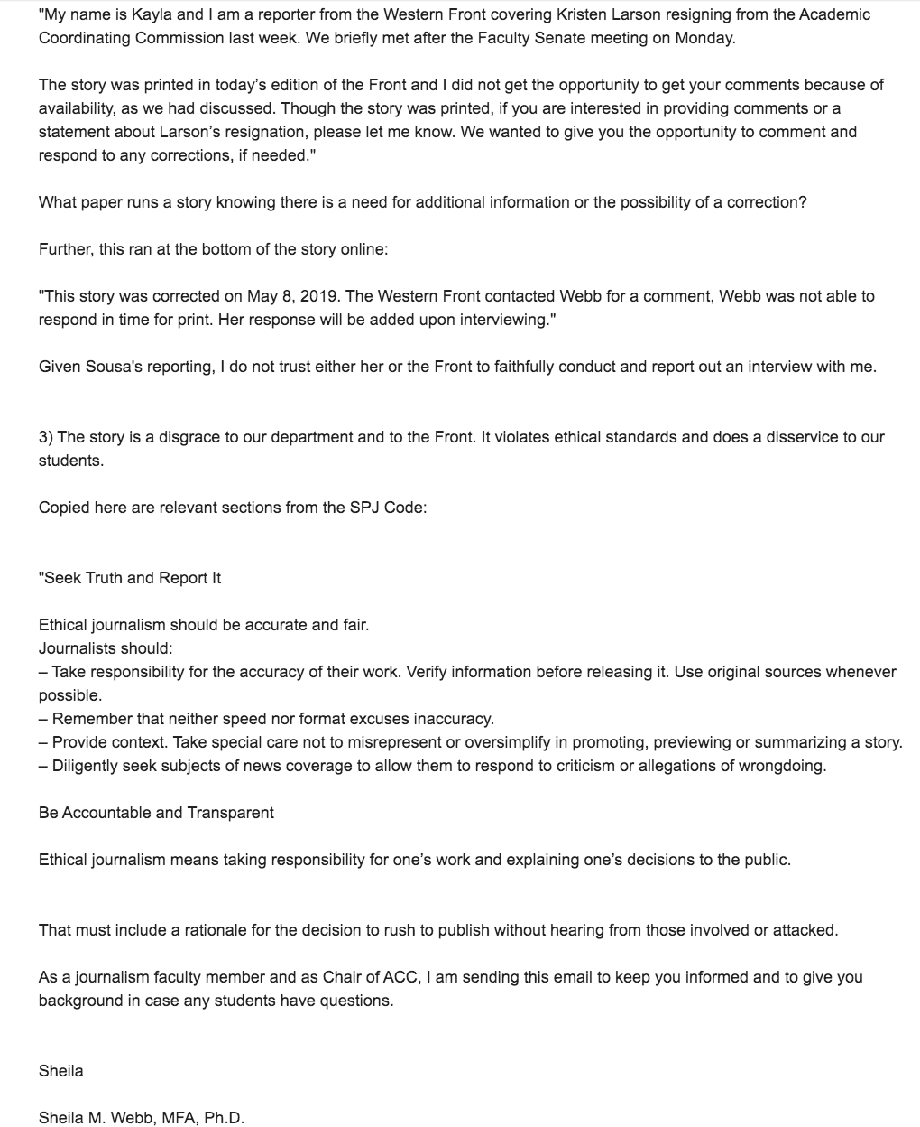
A memo sent to the journalism faculty regarding our department-wide meeting on June 7.

To: Journalism Faculty
From: Esther Chong, Kayla Sousa, Stella Harvey, Laura Place and Julia Berkman
Date: June 5, 2019
Subject: Friday Meeting Regarding ACC Story

Dear Journalism Faculty,

We are writing to you regarding the meeting scheduled for Friday, June 7. Over the last few weeks, we have been dealing with the fallout from the ACC story published on May 8. Throughout this process we have felt intimidated, overlooked and humiliated at the hands of faculty, in and out of this department.

We have provided you with a timeline to catch you up on the events that we will be referencing in this meeting. Please read it in its entirety before coming. We will be discussing the events outlined in the timeline, the lack of actions taken in response, and the lack of support we received.

Our goal in calling this meeting is to have a space to voice our concerns and feelings about the way we have been treated, and shed a light on some of the broader concerns we have about the Journalism department. Our goal is to hear from faculty, and be heard by faculty who have been at the perimeter of these events.

We deserve to be heard.

We have prepared statements we will share with you at the beginning of this meeting. We have also prepared questions to allow for a longer discussion and help us better understand each other’s point of view.

Concerns and points of discussion

- Emails sent calling out a specific student, leaving out the top editors whose responsibility is choosing which stories to publish and to diligently proofread all stories published
- Refusing to allow a student reporter and student editor an opportunity to learn by being a part of a meeting concerning the revision story
- Bringing a previous assignment and referencing scholars week to intimidate a student journalist
- Multiple faculty standing by while defamation and racism against students occurred in front of them

Third-party mediator report from the department-wide meeting regarding this situation on June 7.

Summary of the Journalism Department Student & Faculty Meeting
June 7, 2019, 10 a.m. – 12 p.m.
Background and Purpose of Meeting:
Five student journalists were involved in an article published on May 8, 2019, in The Western Front (Front), WWU’s student-run newspaper. Three of the students involved in writing or publishing the article are students of color, and two of the students are white. The article received several strong negative responses, including one by one tenured Journalism Department (Dept.) faculty member, Sheila Webb, which publicly named and defamed a student by name via email to WWU Dept. faculty, the Faculty Senate President, the Provost and the President. All negative responses were from white faculty in positions of power at WWU. The students promptly made efforts to correct errors or mistakes made in the writing and publishing of the article.
Through this process, the students felt overwhelmingly unsupported by Dept. faculty, individually attacked by Dr. Webb, and felt they were individually treated differently based on their race. The purpose of this meeting was for (1) the students to share their individual personal statements with the faculty about how this process affected each, and (2) for the faculty to listen, and then share their responses with the students. Department Chair, Jennifer Keller, hired Sheri Russell of Bellingham Mediation & Consulting, to facilitate this meeting, and invited all Department faculty to attend.
Attendees:
Students: Kayla Sousa, Esther Chong, Laura Place, Stella Harvey, and Julia Berkman
Faculty: Jennifer Keller, Joan Connell, Joe Gosen, John Harris, Stephen Howie, Jack Keith, Maria McLeod, Derek Moscato, Carolyn Nielsen, Betsy O’Donovan, Peggy Watt and Sheila Webb.
Ground Rules: (Approved by attendees.) 1. Listen when others are speaking. 2. Allow students to read their personal statements without interruption. 3. Strive for dialogue, not debate. 4. Speak for yourself, not for the group. 5. We will not define or discuss the definitions of racism, white privilege or white supremacy.
Students’ Personal Statements: Four of the five students read a prepared statement and the fifth student spoke directly to the faculty. The students’ statements taken together are summarized as follows:
1. Students felt unsupported by all Dept. faculty as a whole. Not one faculty member stood up for or defended the students despite the fact that one or more students were specifically and publicly named, criticized and shamed by Webb.. Likewise, no faculty member condemned Dr. Webb’s public criticism, naming and shaming a specific student.

2. The strong negative response, name-calling and aggressive language was used by white faculty in positions of power at WWU, including faculty who will be teaching courses the students will take next year.

3. The response and those involved, resulted in students feeling terrified, scared, intimidated, humiliated, shamed, vulnerable and fear for their standing and future at WWU. Esther felt they may need to change their major or leave WWU. Students felt their existence at WWU may be negatively impacted, including their grades, reputation, ability to take classes, and reception of scholarships.

4. Students at all times acknowledged and took ownership for their mistakes in the writing and publication of the initial ACC article, and promptly took steps to correct their mistakes.

5. None of the faculty that negatively responded to the article ever spoke with the students or allowed corrections before publicly naming and criticizing the students. Faculty should have spoken directly to the students involved and their advisors. Faculty should not have written public emails about this issue and should not have named any students individually.

6. WWU faculty (non-Dept.) continued to negatively impact the students by blocking their efforts to correct their mistakes and not letting the students of color who wrote the article into a meeting that was specifically to correct the mistakes. Dept. faculty were aware of those actions and did not stand up for the students or advocate for the students being allowed to attend the meeting and correct their mistakes.

7. Through this process of dealing with the strong negative response to the article and trying to correct it, one or two faculty members publicly supported the two white students, and specifically did not support the two students of color. Some faculty members reached out to the white students involved and publicly supported them in email correspondence to other Dept. faculty. Some faculty asked the white students to forward communications to the students of color instead of communicating directly with them.

8. The Dept. is entirely white. The students feel that is the lens through with students are viewed. In addition to this current situation and how some faculty supported only the white students involved.

The students felt the department was concerned with protecting Webb’s reputation more than that they claimed to be concerned about the mistakes made in the coverage. One student of color described a mistake made last year reporting on the Black Student Union (BSU) and not including voices from BSU members. The student said not one Dept. faculty member caught that mistake or suggested including a quote from a BSU member.

9. One white student pointed out that she was the only student copied on Dr. Webb’s email, and not the students of color who wrote the article.

10. Students shared their perspectives of how the Faculty Senate President (FSP) responded to their article and efforts to correct their mistakes. They felt the FSP was inappropriate, unprofessional and ignorant to WA’s Open Meetings Law. They felt the Dept. faculty should have also condemned her actions and supported the students.

11. Faculty should support and mentor students’ successes as well as their mistakes. Students need faculty mentorship to help them with the Front. They do not feel the current Front advisor helps or mentors them “at all.” Thus, students go to other faculty with issues. Students feel overwhelmed working on the Front while also taking classes and some also having part-time employment.

12. The abuse and harassment the students endured far overshadowed any possible learning opportunity.

13. They specifically expressed that they were asked to set aside their feelings of discrimination and targeting of students of color and instead were told to prioritize journalism and correcting the article.

14. Anonymous packages were sent to several students, which only added to the drama and overwhelming feelings from this incident.

15. In a subsequent meeting between students and faculty trying to correct the mistakes, Dr. Webb brought up a past project one of the white students successfully completed last year. The student felt Dr. Webb’s action was meant to intimidate the student.

16. Faculty should not air their interpersonal conflicts with their peers in the classroom in to students. This affects students and their academic relationships with faculty.
Faculty Responses: Twelve of the thirteen Dept. faculty were present. Their responses to the students’ statements taken together are summarized as follows:
1. Faculty had no idea how deeply and personally affected the students were as a result of this whole process.
2. Many faculty members expressed deep regret and their apologies to the students. Some faculty members said they were ashamed at their own behaviors at not defending the students and not condemning the personal attacks against them.
3. Most faculty members verbally condemned Dr. Webb’s public criticism and naming of the student reporter via email to WWU faculty, the Faculty Senate President, the Provost and the President.
4. Some faculty members said they were shocked and personally condemned Dr. Webb’s public email, but they felt they would be “throwing fuel onto the fire” by jumping into the email correspondence and sharing their thoughts.
--Students responded by saying the faculty’s silence was interpreted as tacit consent, non-support and that they did not care about the students.
5. Several faculty members said they had never seen such an email as the one Dr. Webb sent.
6. One faculty member tried to explain their email that contributed to this process.
--However, the students were visibly upset by this faculty member’s statements, and responded that the faculty member was missing the point.
7. One faculty member said they had shattered the students’ trust and the onus is on the faculty. 8. (Students specifically asked Dr. Webb to respond to their personal statements and the responses from the faculty. Dr. Webb had been silent during the faculty responses.) Dr. Webb said she “was sorry to hear about the students’ pain” and apologized to the one student for bringing up her past project at the meeting. She explained that she wore two hats – a Dept. faculty member and also the Chair of the Academic Coordinating Commission (ACC). She defended her email, saying the article at issue criticized the honorable efforts of the ACC. She said she thought she was being transparent by sharing her email with the white student. This student was one of the editors. Dr. Webb explained that typical procedure for issues with articles is to speak with the editors, not the reporters. Dr. Webb said she should not be grouped together with the Faculty Senate President.
--Students responded that Dr. Webb had not apologized for her actions and her email. She only apologized to the one white student for bringing up her past project. Dr. Webb did not acknowledge how her actions have affected the students.

(Note: After the students shared their feedback of Dr. Webb’s statements directly to her, and before this meeting ended, Dr. Webb silently left the meeting when another faculty member had to leave. The other faculty member let the students and faculty know ahead of time that she needed to leave early.)

Two students witnessed Dr. Webb roll her eyes as she stood and left the room, unannounced.
Suggestions for Improvement: The students felt many things need to be improved in the Dept. and its advising and mentoring of students working for the Front. They felt that needed to be a separate conversation and wanted to focus on this current incident. Nonetheless, through the personal statements, comments and discussion, the following suggestions were made:
1. The curriculum should be revised to require students to take classes on law, ethics, reporting, and diversity and inclusion prior to reporting for the Front.
2. Students would like to have input into curriculum revisions.
3. Students would like more training on how to report on and respond to diversity issues. They feel diversity issues should be incorporated into every course, not just one reading or a 1-hour training.
4. Protocols need to be established for how faculty interacts with the Front and the Front’s advisor.
5. The Front’s student reporters and editors need faculty mentoring and guidance – general and to flag concerns with stories.
6. The Front’s student reporters and editors need guidance on how to interact with and respond to people in positions of power.
7. Students want faculty to stand up for students and be supportive in helping them correct mistakes.
Students’ Feedback: Students appreciated faculty members’ attending this meeting, listening to their perspectives without interrupting and for sharing their responses.
The students appreciated the faculty members who apologized and took ownership for their silence in not defending the students and not condemning those whose behaviors were inappropriate and unprofessional.
After all faculty members left, the students said they felt the purpose of the meeting had been accomplished, and they felt the meeting went and ended better than they expected.
They had a significantly reduced amount of fear of having negative academic and social repercussions next year from the Dept. faculty.
They appreciated Dept. Chair Keller hiring a facilitator for this meeting and respecting the seriousness of this process and outcome.

